RDP Configuration Guide for
Windows Server 2016

This guide is intended for the purpose of building up a common RDP server, it is not for use in other advanced purposes.
Please follow this guide to set up a Session Host and/or Virtual Host server properly. The configurations might vary in different Windows server OS versions.

Summary:
1 Add Roles (Remote Desktop Session Host) 2
2 Configure Remote User Authentication In “Control Panel”. 6
3 Configure “Windows Firewall” in “Control Panel”. 9
4 Group policy setting for system optimization. 10
5 Reboot the system. 21

Add Roles (Remote Desktop Session Host)

Launch “Server Manager”

Click “Add roles and features”
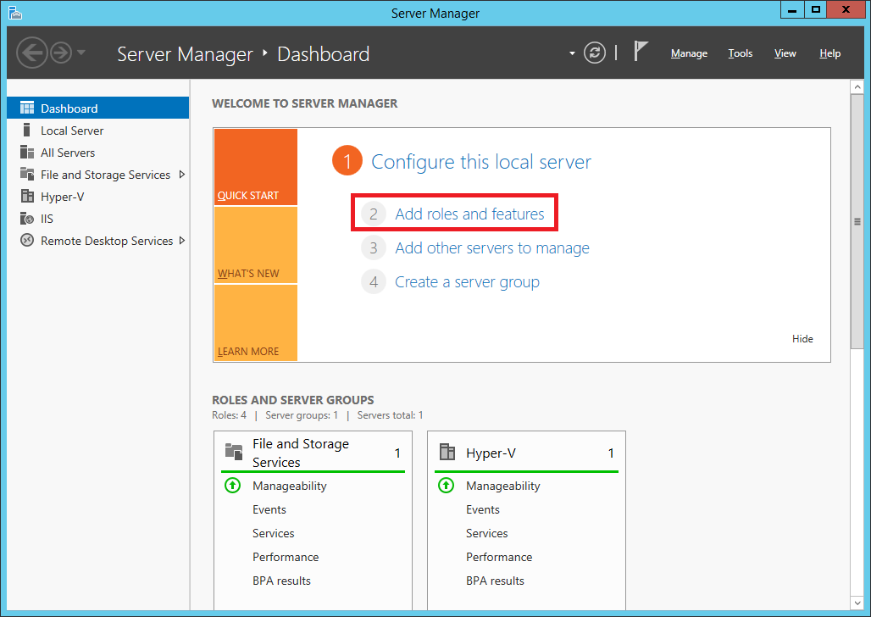

Click “Next”
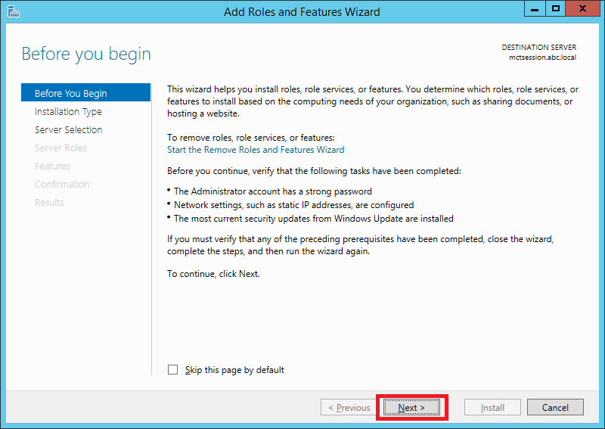

Click “Role-based or feature-based installation”

Click “Next”
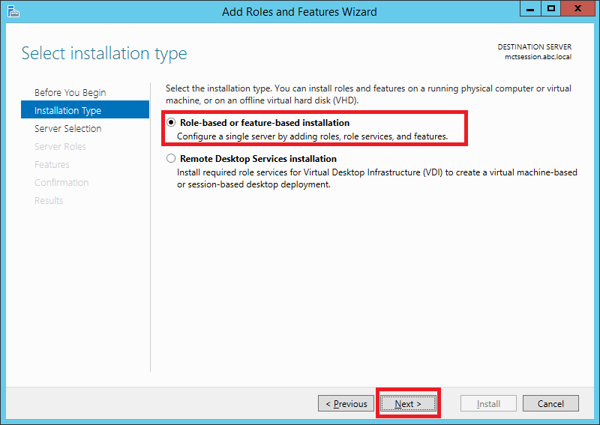

Click “Select a server from the server pool”

Click “Next”
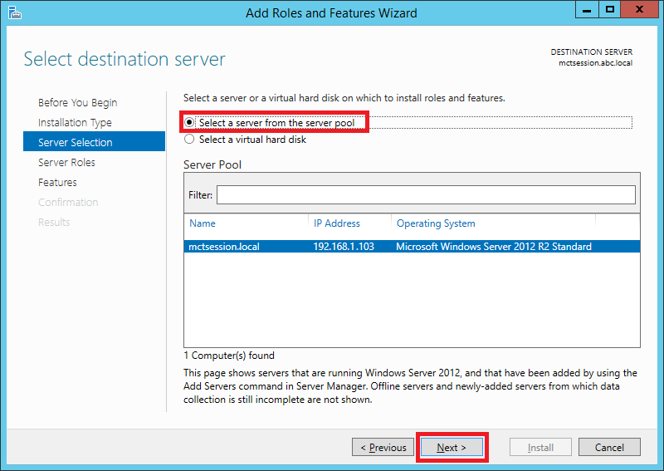

Expand “Remote Desktop Services”

Check “Remote Desktop Session Host”

Click “Next”

Click “Install”
Note: Once you click “Install” the system will initiate the “Role and Feature” installation process. Please reboot the system once the status shows installation successful.

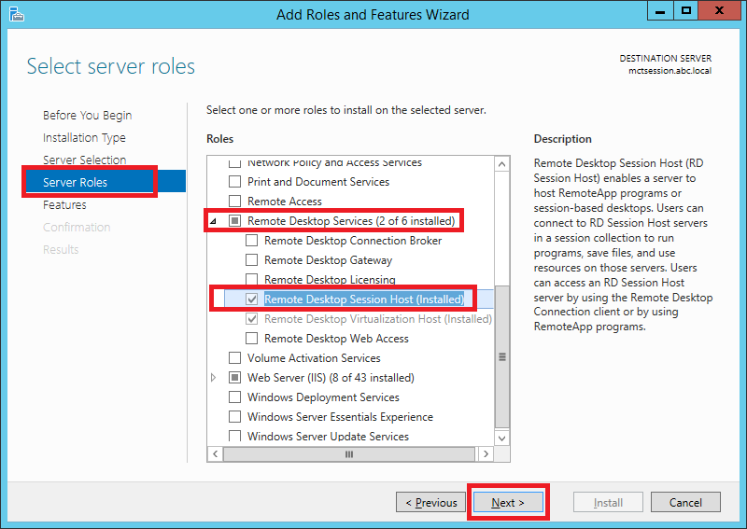

Launch “Server Manager” to verify the “Remote Desktop Session Host” is installed successfully
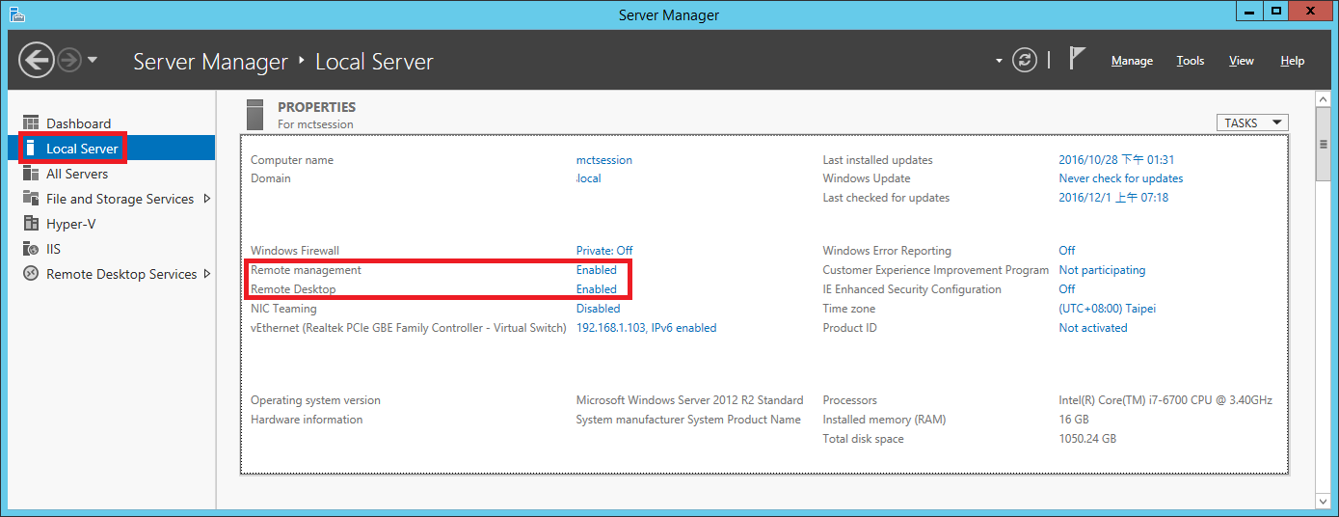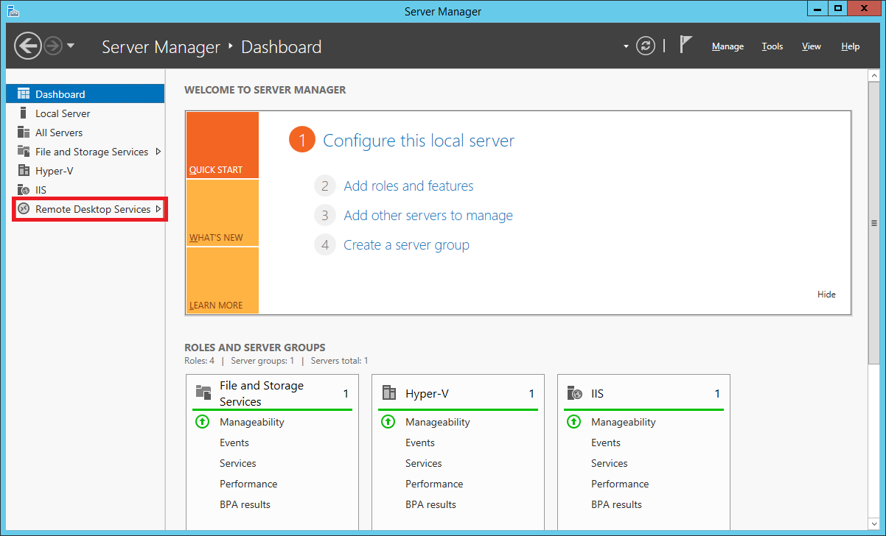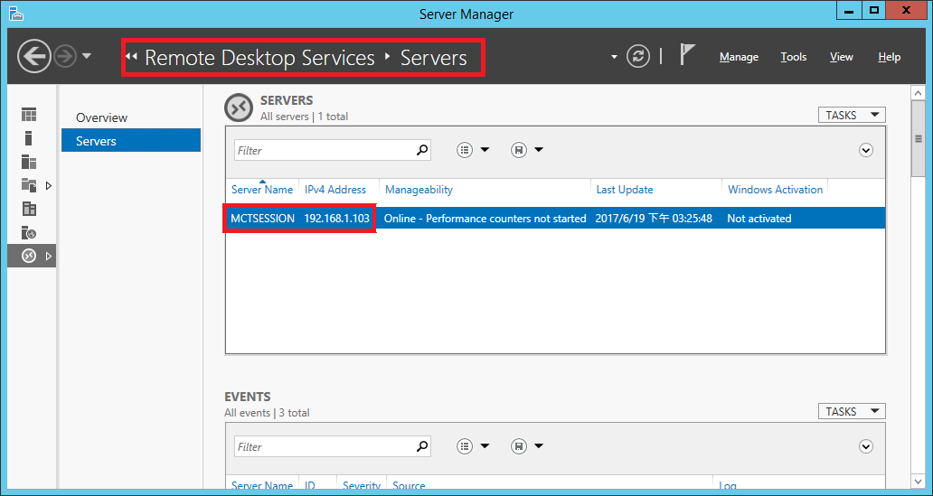

Configure Remote User Authentication in “Control Panel”

Configure “Remote settings”

Go to “Control Panel \ System and Security \ System”

Click “Remote settings”
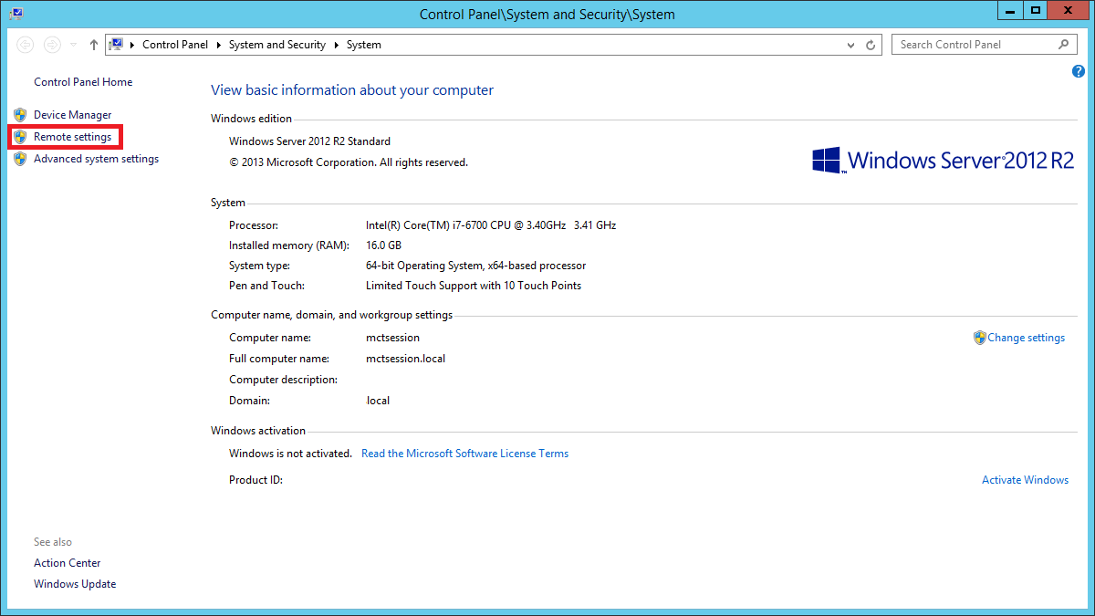

Click the “Remote” tab

Select “Allow remote connections to this computer”

Uncheck “Allow connections only from computers running Remote Desktop with Network Level Authentication (Recommended)”
Note: This will allow the user remote access to the host without entering a user name and password in the client connection settings.

Click “Select Users…”
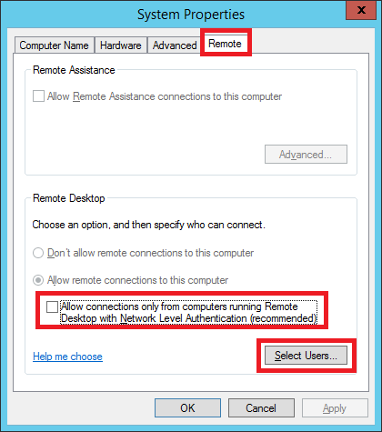

Click “Add”

Click “Advanced...”
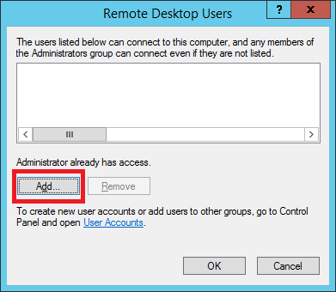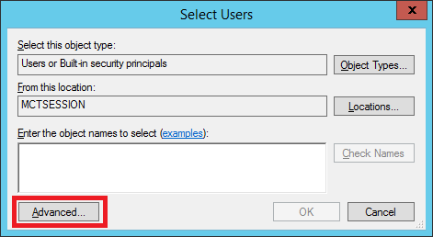

Click “Find Now”

Select users to assign who has permission to remote access this pc

Click “OK”
Note: Choose “Everyone” to require all existing users to obtain remote access authority from the host.
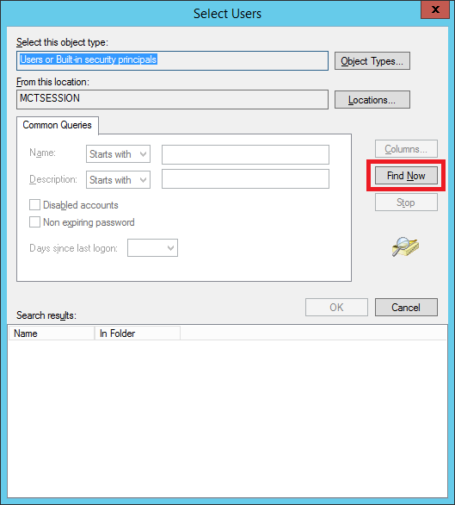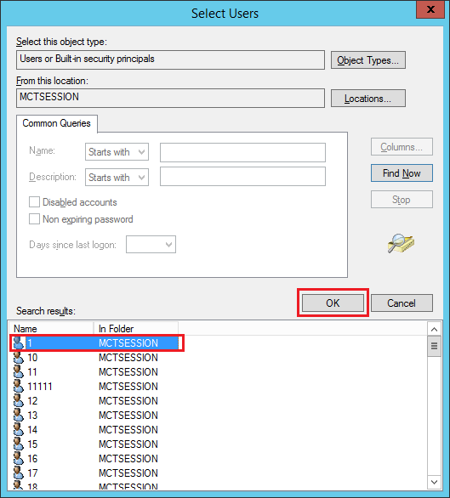

Click “OK” in the Select Users dialog

Click “OK” in the Remote Desktop Users dialog
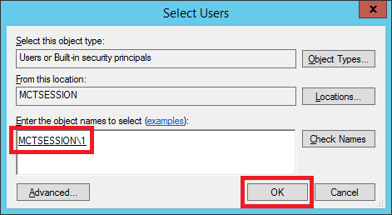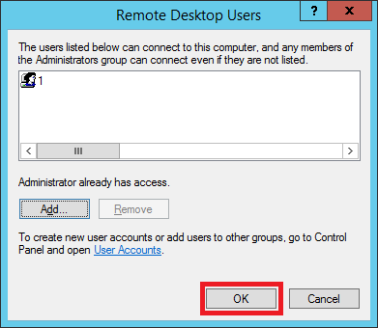

Configure the “Windows Firewall” in the “Control Panel”

Go to path “Control Panel\System and Security\Windows Firewall”

Click “Allow an app or feature through Windows Firewall”
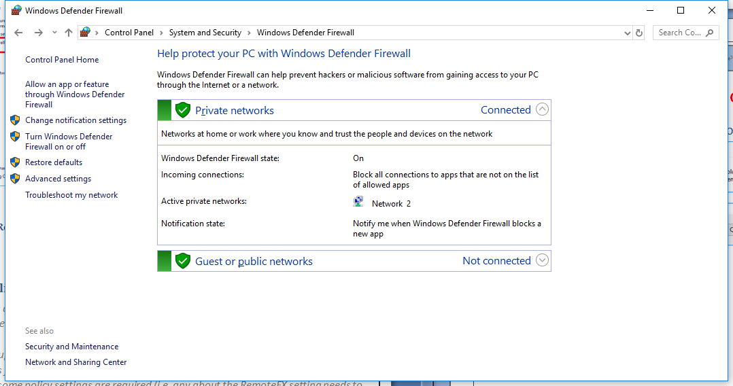

Select “Remote Desktop” and choose: “Domain”, “Private”, “Public”

Select “Remote Desktop Services” and choose: “Domain”, “Private”, “Public”

Select “Remote Desktop Virtualization Host Agent” and choose: “Domain”, “Private”, “Public” if user have install the Virtualization Host service.
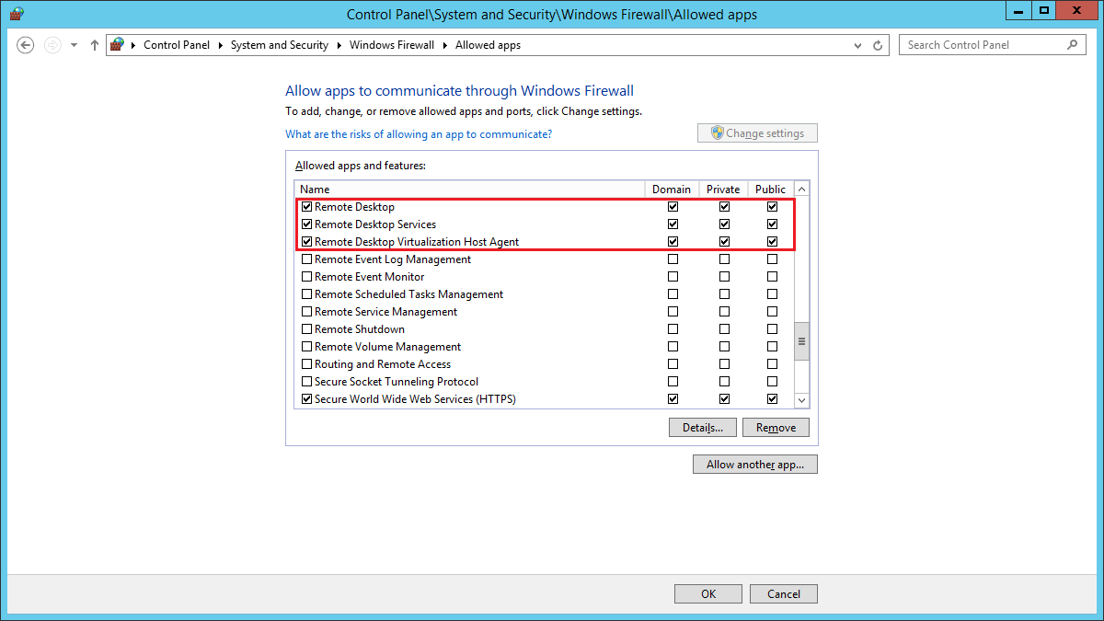

Group policy setting for system optimization
The following is a list of policy changes required to lower CPU utilization while maintaining the RDS session video and audio quality on a Windows Server OS.

Launch the group policy editor “gpeditmsc” as an administrator on the Windows Server. Below are suggestions for getting better performance between the Session Host or Virtual Host and the RDP client, some policy settings are required (i.e. any about the RemoteFX setting needs to be enabled). Please refer to the text in red below to enable or disable the required policy settings.

Launch the Local Group Policy Editor

Press the Windows key 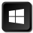 + R.

Enter “gpedit.msc”

Click “OK” to launch

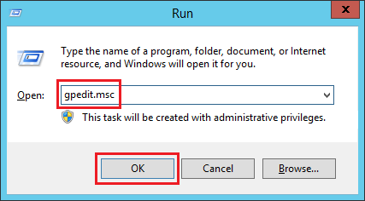

Enable “Allow RDP redirection of other supported RemoteFX USB devices from this computer”

Expand the path “Computer configuration >> Administrative templates >> Windows components >> Remote Desktop Services >> Remote Desktop Connection Clients >> RemoteFX USB Device Redirection”

Double click “Allow RDP redirection of other supported RemoteFX USB devices from this computer”

Select “Enabled”
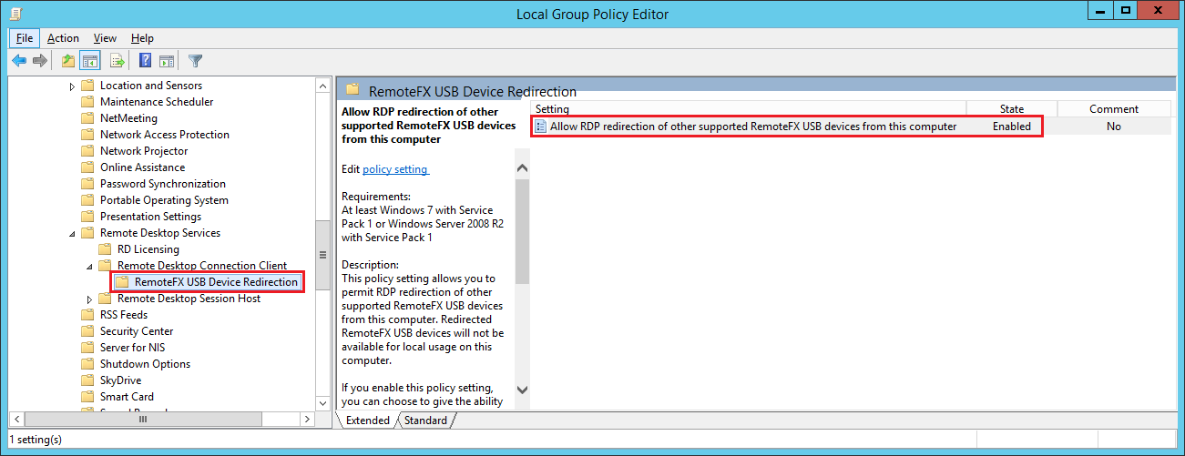
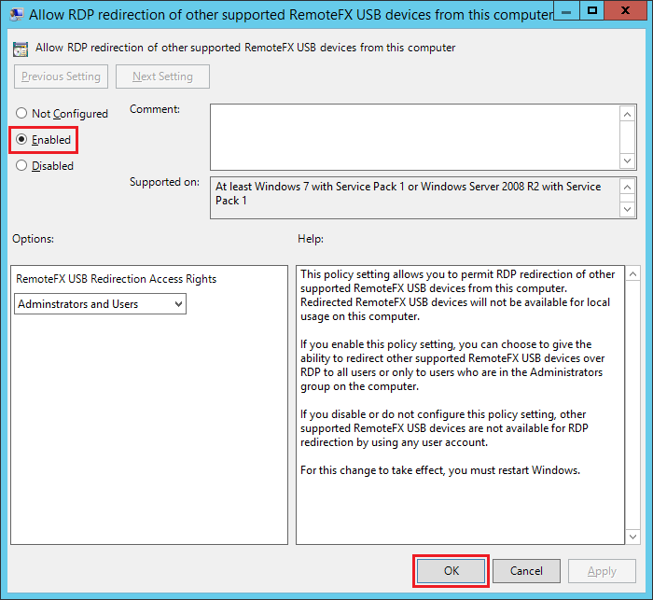

Enable “Allow audio and video playback redirection”

Expand the path “Computer configuration >> Administrative templates >> Windows components >> Remote Desktop Services >> Remote Desktop Session host >> Device and Resource Redirection”

Double click “Allow audio and video playback redirection”

Select “Enabled”
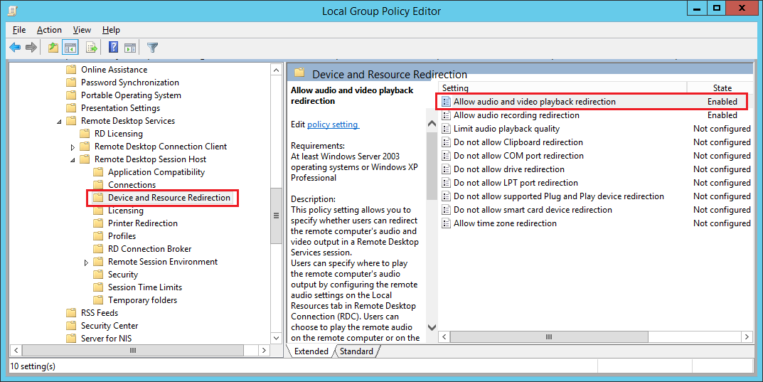
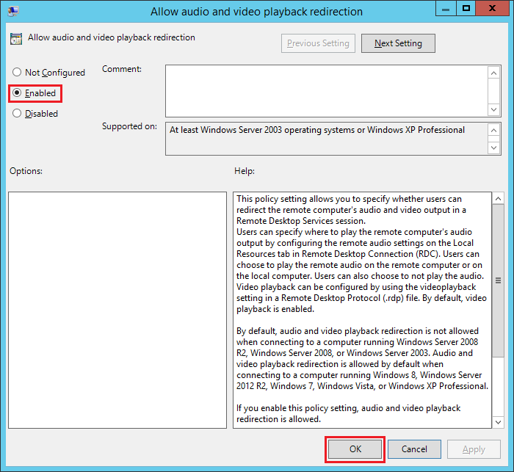

Enable “Configure RemoteFX”

Expand the path “Computer configuration >> Administrative templates >> Windows components >> Remote Desktop Services >> Remote Desktop Session host >> Remote Session Environment >> RemoteFX for Windows Server 2008R2”

Double click “Configure RemoteFX”

Select “Enabled”
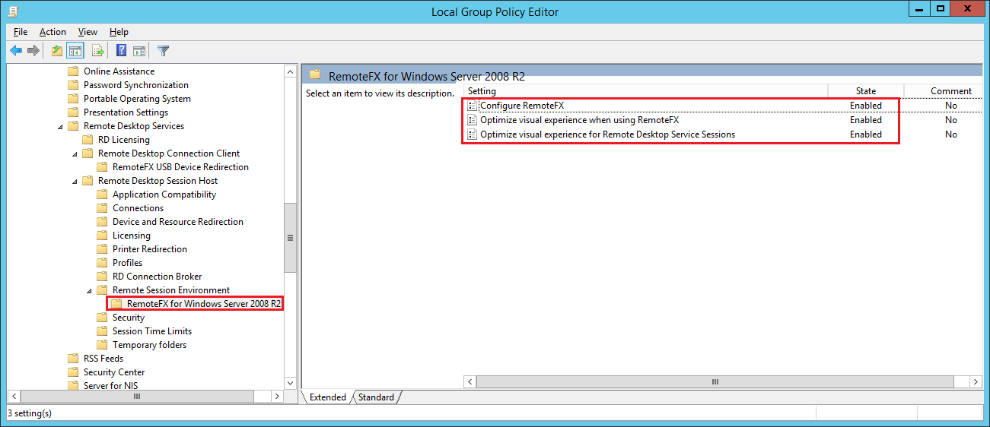
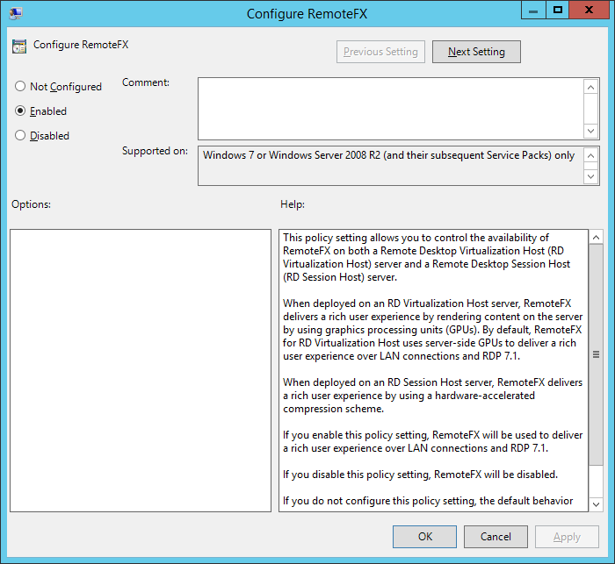

Enable and set “Optimize visual experience when using Remote FX”

Expand the path “Computer configuration >> Administrative templates >> Windows components >> Remote Desktop Services >> Remote Desktop Session host >> Remote Session Environment >> RemoteFX for Windows Server 2008R2”

Double click “Optimize visual experience when using Remote FX”

Select “Enabled”
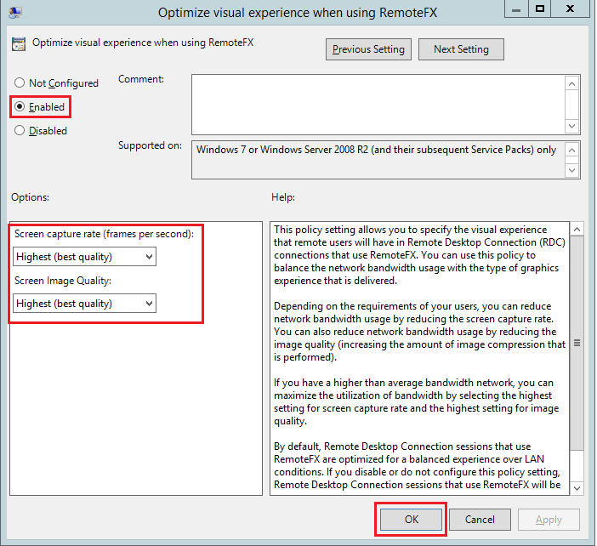

Enable and set “Optimize visual experience for Remote Desktop Service Sessions”

Expand the path “Computer configuration >> Administrative templates >> Windows components >> Remote Desktop Services >> Remote Desktop Session host >> Remote Session Environment >> RemoteFX for Windows Server 2008R2”

Double click “Optimize visual experience for Remote Desktop Service Sessions”

Select “Enabled”

Set “Visual experience” to “Rich Multimedia”
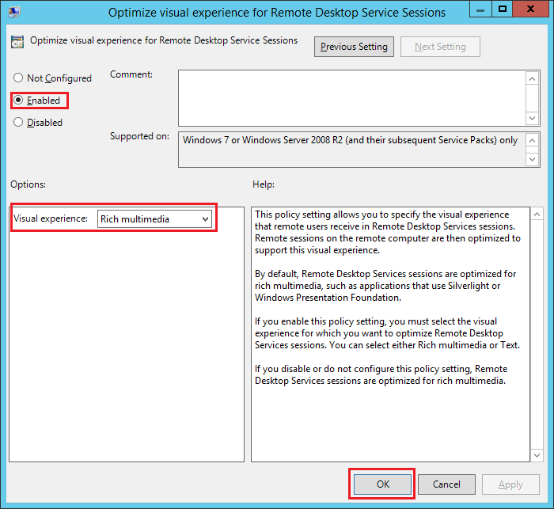

Enable “Limit maximum color depth”.

Expand the path “Computer configuration >> Administrative templates >> Windows components >> Remote Desktop Services >> Remote Desktop Session host >> Remote Session Environment”

Double click “Limit maximum color depth”

Select “Enabled”

Set “Color Depth” to “32 bit” or “Client Compatible”
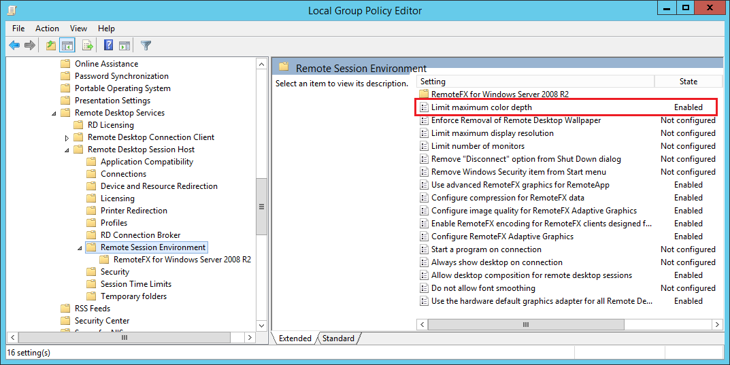
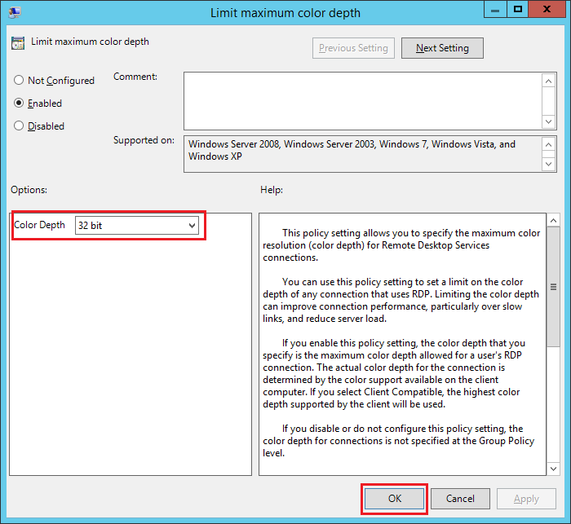

Enable “Enable RemoteFX encoding for RemoteFX clients designed for Windows Server2008R2 SP1”

Expand the path “Computer configuration >> Administrative templates >> Windows components >> Remote Desktop Services >> Remote Desktop Session host >> Remote Session Environment”

Double click “Enable RemoteFX encoding for RemoteFX clients designed for Windows Server2008R2 SP1”

Select “Enabled”
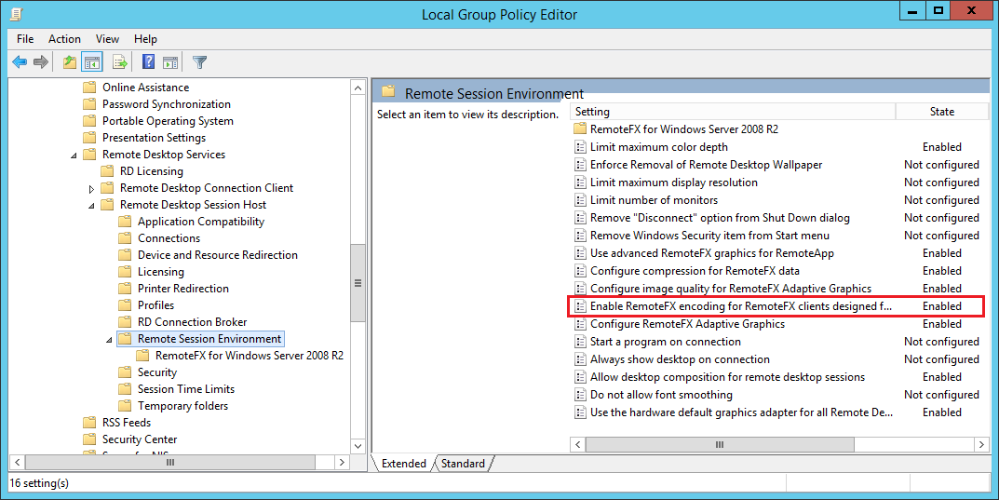
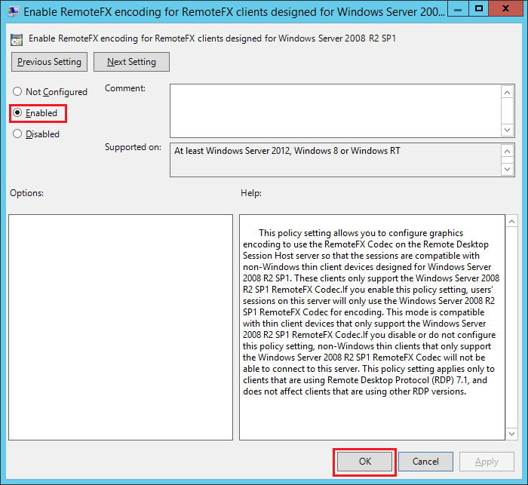

Enable “Use the hardware default graphics adapter for all Remote Desktop Services sessions”

Expand the path “Computer configuration >> Administrative templates >> Windows components >> Remote Desktop Services >> Remote Desktop Session host >> Remote Session Environment”

Double click “Use the hardware default graphics adapter for all Remote Desktop Services sessions”

Select “Enabled”
Note: Enabling this policy might affect your remote connections. Disabling or enabling this policy will decide the connection decoded by the CPU or GPU.
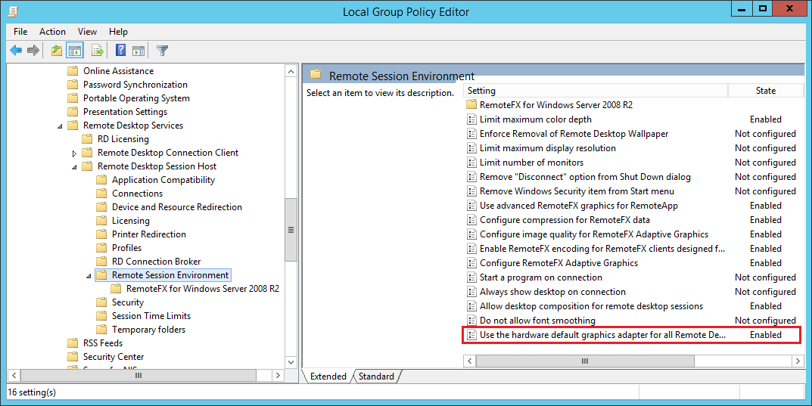
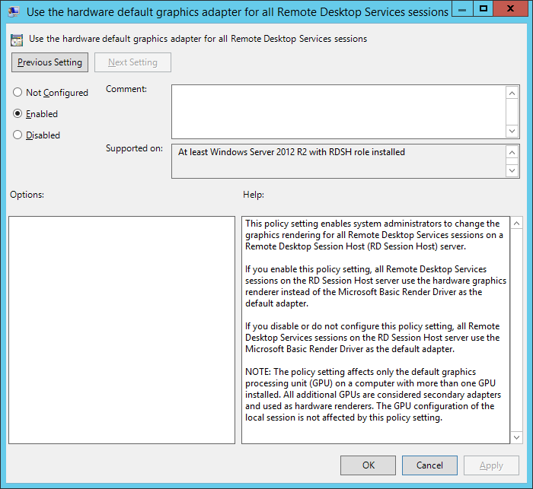

Enable “Configure compression for RemoteFX data”

Expand the path “Computer configuration >> Administrative templates >> Windows components >> Remote Desktop Services >> Remote Desktop Session host >> Remote Session Environment”

Double click “Configure compression for RemoteFX data”.

.Select “Enabled”

Set RDP compression algorithm to “Do not use an RDP compression algorithm”

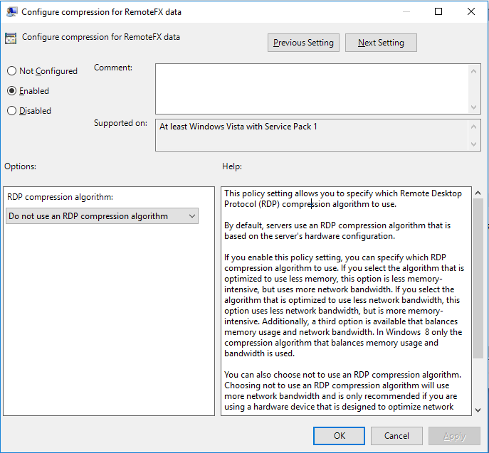

Enable “Configure RemoteFX Adaptive Graphics”

Expand the path “Computer configuration >> Administrative templates >> Windows components >> Remote Desktop Services >> Remote Desktop Session host >> Remote Session Environment”

Double click “Configure RemoteFX Adaptive Graphics”.

.Select “Enabled”

Set RDP Experience to “Optimize for server scalability”

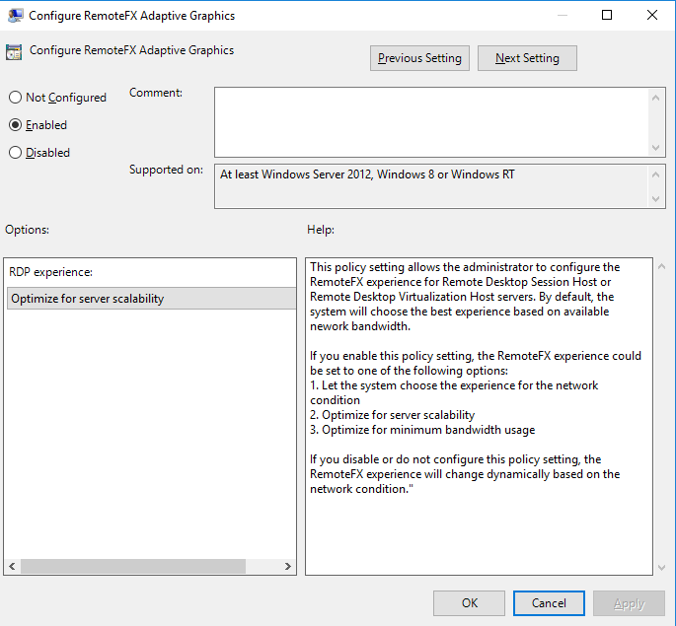

Enable the policy “Require use specific security layer for remote (RDP) connections”

Expand the path “Computer configuration >> Administrative templates >> Windows components >> Remote Desktop Services >> Remote Desktop Session host >> Security”

Double click “Require use specific security layer for remote (RDP) connections”.

Select “Enabled”

Set the “Security Layer” to “Negotiate”
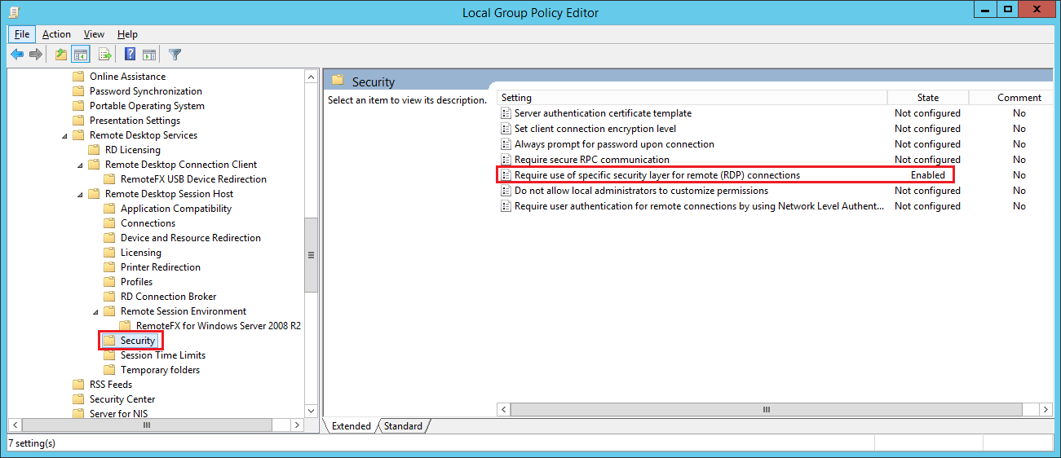
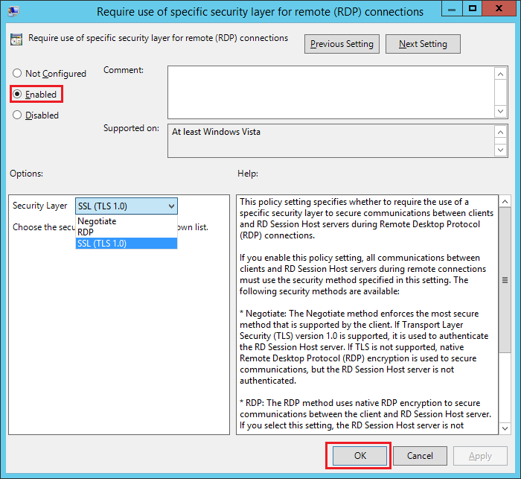

Reboot the system

Reboot the system to complete the Remote Desktop configuration and to be able to allow the client remote access

